https://www.hackerearth.com/practice/basic-programming/input-output/basics-of-input-output/practice-problems/algorithm/count-divisors/

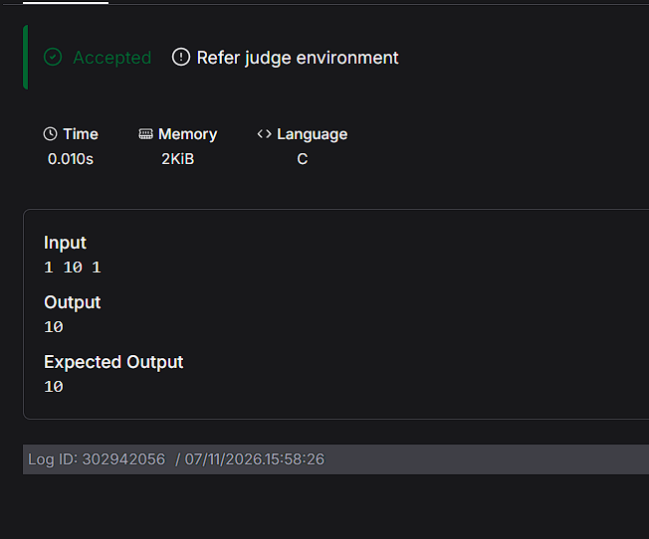
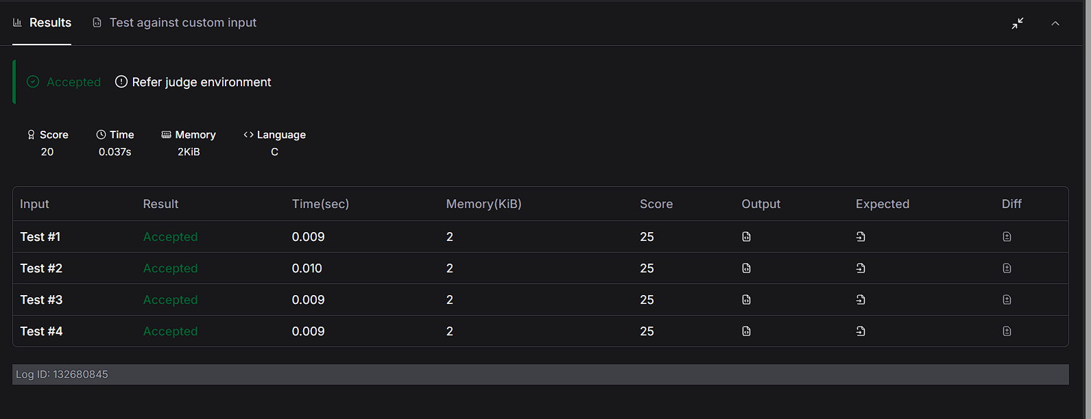
CODE:
#include <stdio.h>

int main() {
int l, r, k;
scanf("%d %d %d", &l, &r, &k);

printf("%d\n", r / k - (l - 1) / k);
return 0;
}

